**Polynomial Fitting Write-Up**

The primary difficulty from this assignment came in verifying that all of the various parts of the program were correct. I knew my horners method code worked as long as it received the correct input, so I had to verify that the input was correct. The biggest bug I had was in my code to derive the polynomials from the matrix result. My resultant polynomials had their coefficients in an order opposite what my horners method code needed. Once I realized that, I just reversed the arrays before I called applied horners method and everything worked out great.

Degree 1

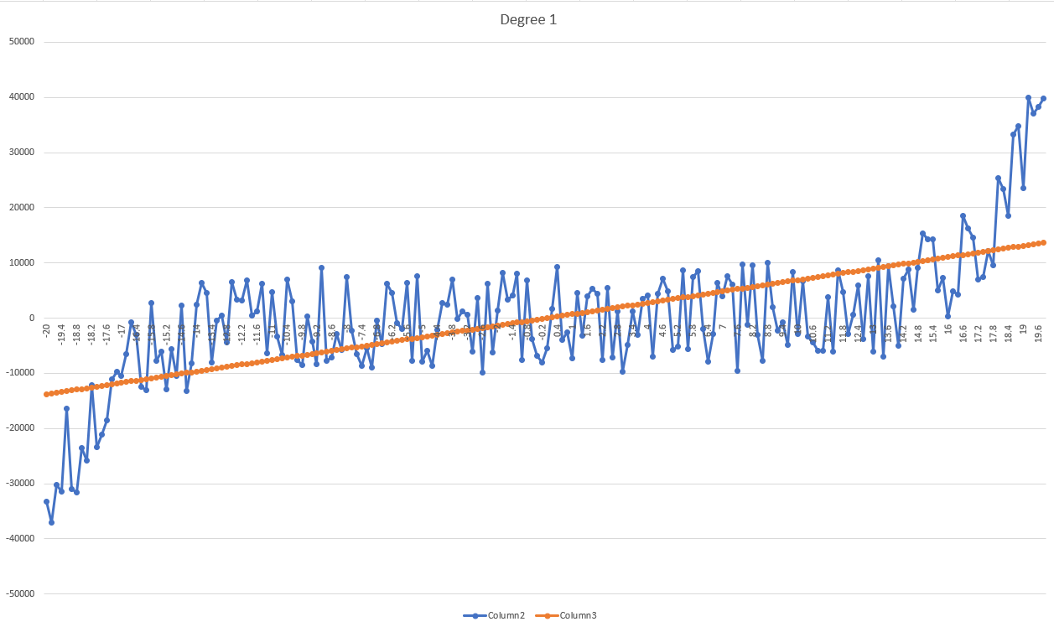

Degree 2

Degree 3

Degree 4

Degree 5

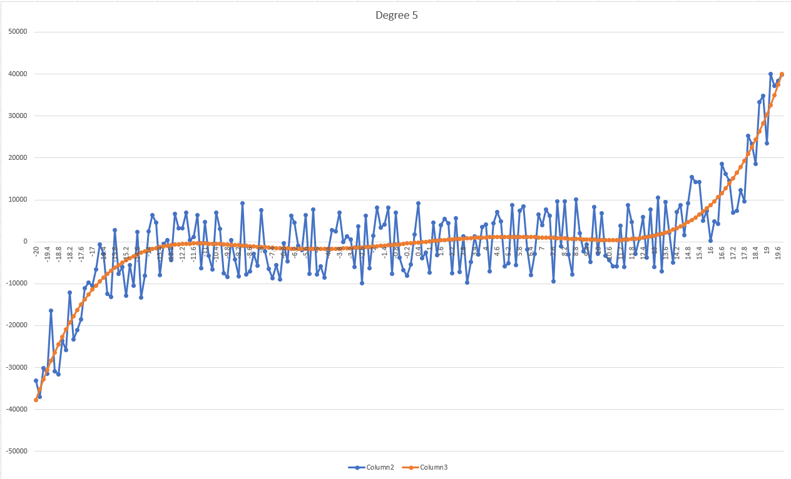

Degree 6

Degree 7

